**Project Design Phase-II**

**Data Flow Diagram & User Stories**

|  |  |
| --- | --- |
| Date | 03 October 2022 |
| Team ID | PNT2022TMIDxxxxxx |
| Project Name | Project - xxx |
| Maximum Marks | 4 Marks |

**Data Flow Diagrams:**

A Data Flow Diagram (DFD) is a traditional visual representation of the information flows within a system. A neat and clear DFD can depict the right amount of the system requirement graphically. It shows how data enters and leaves the system, what changes the information, and where data is stored.

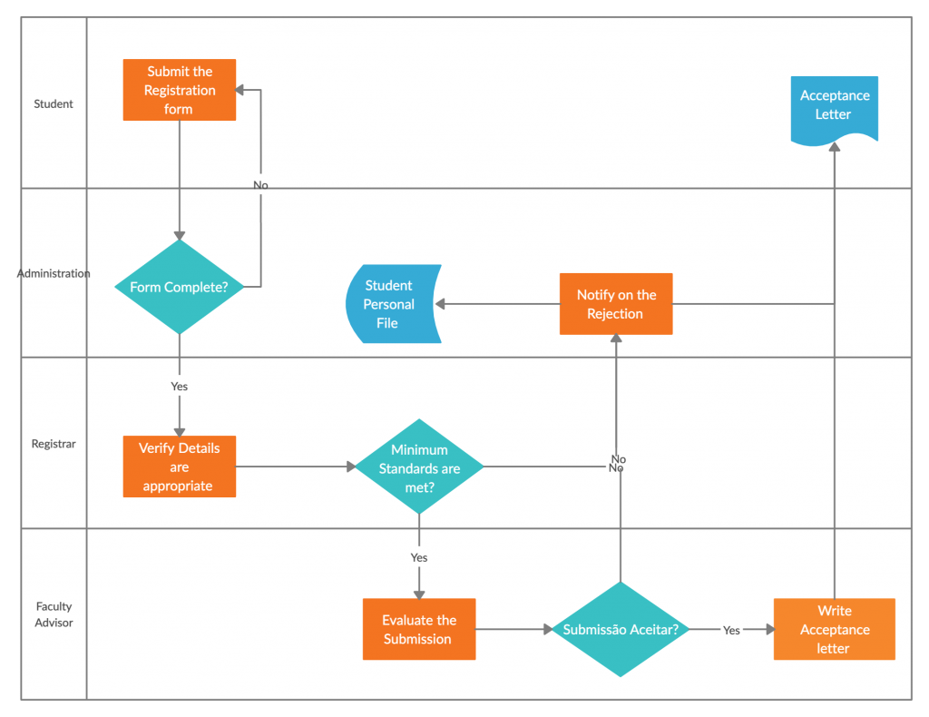

**User Stories**

Use the below template to list all the user stories for the product.

| **User Type** | **Functional Requirement (Epic)** | **User Story Number** | **User Story / Task** | **Acceptance criteria** | **Priority** | **Release** |
| --- | --- | --- | --- | --- | --- | --- |
| Customer (Mobile user) | Registration | USN-1 | As a user, I can register for the application by entering my email, password, and confirming my password. | I can access my account / dashboard | High | Sprint-1 |
|  |  | USN-2 | As a user, I will receive confirmation email once I have registered for the application | I can receive confirmation email & click confirm | High | Sprint-1 |
|  |  | USN-3 | As a user, I can register for the application through Facebook | I can register & access the dashboard with Facebook Login | Low | Sprint-2 |
|  |  | USN-4 | As a user, I can register for the application through Gmail |  | Medium | Sprint-1 |
|  | confirmation | USN-5 | Confirmation via email or otp | I can confirm my email | High | Sprint-1 |
|  | Visualizing data |  | User can visualize the trend datsathrough data connected through IBM cognos Analytics | I can visualize my data | high | Sprint 1 |
| Customer (Web user) | Check out |  | the HMS helps facilities in ensuring all the information | I can checkout my information through IBM cognos | medium | Sprint 2 |
| Customer Care Executive | Generating report |  | Users can view health report and can make decisions | I can ger=nerate my own report | medium | Sprint 1 |
| Administrator |  |  |  |  |  |  |
|  |  |  |  |  |  |  |
|  |  |  |  |  |  |  |
|  |  |  |  |  |  |  |